STREATHAM HUB DEVELOPMENT

Newsletter No. 1 - July 2011

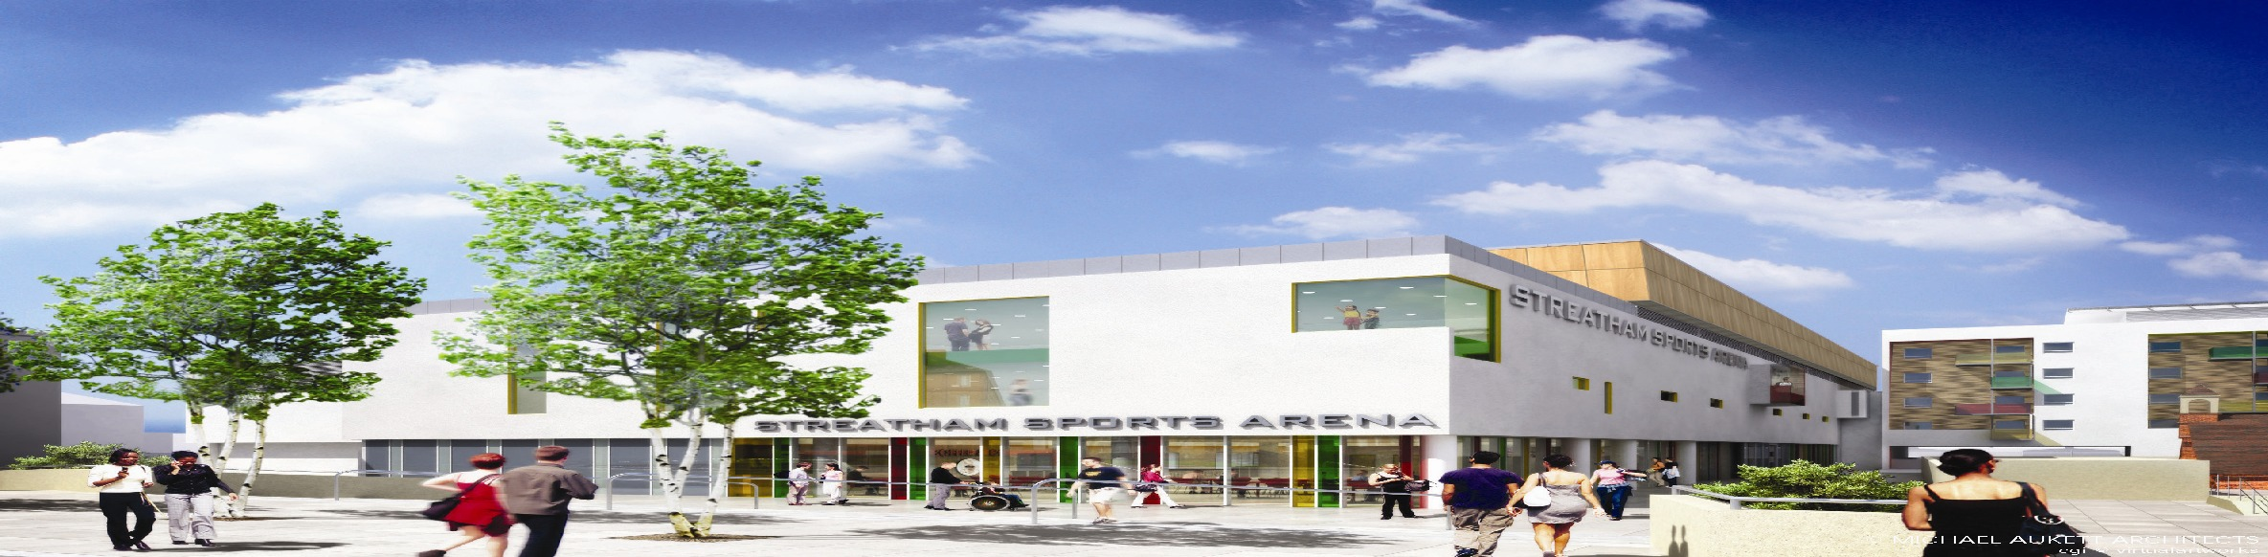

Dear Neighbour

We are pleased to advise that VINCI Construction UK Ltd have been appointed to construct the exciting new Streatham Hub development. This includes a new Leisure Centre for the residents of London Borough of Lambeth, featuring an ice rink, swimming pool, sports hall and fitness centre. The remainder of the development comprises a retail store, new Bus Interchange adjacent to Streatham Railway Station and a mix of private, shared ownership and affordable residential accommodation, all served by an underground car park. Public spaces will be incorporated around the Streatham United Reform Church.

The project will start in the next few weeks, and the initial works will be the erection of perimeter hoardings followed by the progressive demolition of the existing buildings. These works are largely due to be completed by the end of the year. We will also be starting a series of alterations to the statutory utilities in the area.

VINCI Construction UK Ltd prides itself on maintaining good relations with the communities in the areas surrounding our projects. Streatham Hub will be underway until late-2013, and we intend to follow best practice in all of our activities in the area. The project will be registered under the Considerate Contractors Scheme, a nationwide standard for good construction practice.

We intend to provide information regularly throughout the project to advise you of progress and explain relevant activities that you will see happening before they start.

In constructing this exciting new project for the future of Streatham there will be challenges to overcome. However, at VINCI Construction UK Ltd, we are fully aware of the impact that the works may have on our neighbours and you can rest assured that we shall take every opportunity to minimise any disruption or nuisance.

In this respect, Peter Muncaster, our Stakeholder Manager, or I can be contacted on the telephone numbers below should you have any queries or concerns.

Steve Diggines
Project Director
VINCI Construction UK Ltd

Peter Muncaster 07816 515788
Steve Diggines 07796 996132
E-mail streathamhub.public@vinciconstruction.co.uk

