Hair Raising Skates
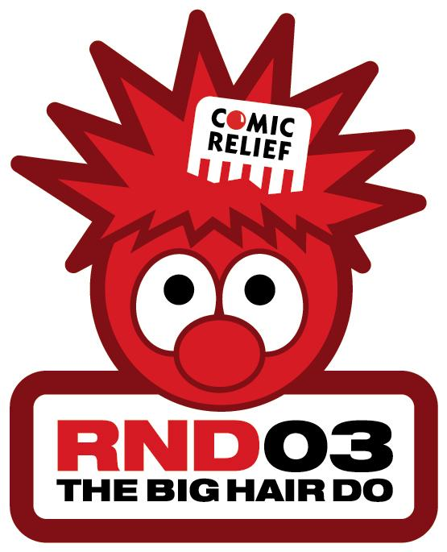
Have fun on Red Nose Day at
Streatham Ice Arena
386 Streatham High Road, London SW16 6HT
Tel: 020 8769 7771

Friday 14th March 2003
Comic Relief registered charity 326568

6-8 p.m.
Entrance fee £4.70 includes skate hire
Non-skating parents/guardians £1.60
- Enjoy the Junior Disco (age 16 and under)
- Sponsored routines by hockey and figure skaters
- Have your face painted red and hair gelled for £1
- Wear something red (50p will be donated if you do)
- Donate for a record dedication …

… Or just come along to watch –
Starburst Ltd will donate 50p to Comic Relief
for every person who comes
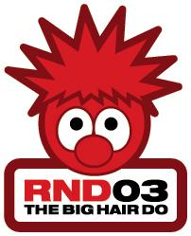

Organised by Streatham Ice Skating Action Group (SISAG).

Thanks to Starburst Ltd for their support.

Hair Raising Skates
Have fun on Red Nose Day at
Streatham Ice Arena
386 Streatham High Road, London SW16 6HT
Tel: 020 8769 7771

Friday 14th March 2003
Comic Relief registered charity 326568

6-8 p.m.
Entrance fee £4.70 includes skate hire
Non-skating parents/guardians £1.60
- Enjoy the Junior Disco (age 16 and under)
- Sponsored routines by hockey and figure skaters
- Have your face painted red and hair gelled for £1
- Wear something red (50p will be donated if you do)
- Donate for a record dedication …

… Or just come along to watch –
Starburst Ltd will donate 50p to Comic Relief
for every person who comes

Organised by Streatham Ice Skating Action Group (SISAG).

Thanks to Starburst Ltd for their support.

